Advanced Econometrics Final Paper

***“How does market sentiment, proxied by the VIX, affect the returns of***

***major ETFs representing different equity market segments?”***

*December 14, 2025*



*Credit: rcbizjournal.com*

# Introduction

Equity markets are driven by two main forces: information and sentiment. While classical asset pricing models primarily focus on fundamental valuations of expected future cash flows, a growing body of research has been investigating the influence investor sentiment, particularly fear and uncertainty, can have on short-term equity returns. The CBOE Volatility Index (VIX), also known as the market’s “fear gauge,” appears among the leading measures of aggregate market sentiment. This index, derived from changes in the price of S&P 500 options, captures investors’ expectations of future market volatility, or implied volatility. As such, VIX is widely used by investment practitioners for hedging and portfolio management. Surprisingly, however, little research has systematically examined how VIX-driven sentiment shocks affect the performance of different equity market segments represented by exchange-traded funds (ETFs).

This study examines how changes in market sentiment, proxied by the VIX, affect returns across major ETFs representing distinct equity segments, including broad market indices, growth and value factors, small-cap equities, sector exposures, and international markets. Drawing on behavioral finance and empirical asset pricing, I hypothesize that increases in market uncertainty exert negative effects on ETF returns, with magnitudes that vary systematically across segments based on risk characteristics, liquidity, and exposure to sentiment-driven flows.

This study makes three primary contributions to the existing literature. First, I provide comprehensive panel evidence on VIX-ETF return relationships across nine major equity market segments over a 20-year period spanning multiple market regimes, including the Global Financial Crisis of 2008 and the COVID-19 pandemic. While prior research has examined either broad market indices or specific volatility products in isolation, no study has systematically compared sentiment sensitivity across broad market, style factor, sectoral, and international ETF categories using a unified empirical framework. Second, I document substantial heterogeneity in volatility sensitivity across market segments, with financial sector and small-cap ETFs exhibiting approximately 35% greater sensitivity than value-oriented funds. This heterogeneity has received limited attention in prior work but carries important practical implications for portfolio construction and risk forecasting. Third, I demonstrate that the VIX-return relationship is asymmetric and regime-dependent: volatility shocks occurring during positive market performance are significantly less damaging than those accompanying market selloffs, revealing that investors do distinguish between "good volatility" reflecting active price discovery and "bad volatility" signaling genuine risk aversion.

The findings strongly confirm the central hypothesis: a one-standard-deviation increase in VIX reduces average ETF returns by approximately 1.36 percentage points, an economically substantial effect representing nearly ten times the average weekly return in the sample. However, this aggregate relationship masks considerable heterogeneity. The financial sector ETF (XLF) exhibits the strongest sensitivity (-0.196), reflecting the sector's inherent leverage and exposure to credit market conditions, while value stocks (VTV) display the lowest sensitivity (-0.142), consistent with their defensive characteristics. The positive and significant interaction term between VIX and market returns reveals that volatility effects are substantially mitigated during market rallies, suggesting asymmetric investor responses to volatility depending on market direction.

The remainder of this paper proceeds as follows. Section II reviews the relevant literature on market sentiment, volatility indices, and ETF performance. Section III first describes the data sources, variable construction, and summary statistics, and then presents the identification strategy. Section IV reports the main empirical findings, including baseline results and heterogeneity analyses. Section V discusses the interpretation and implications of these results, acknowledges limitations, and suggests avenues for future research.

# Literature Review

This study builds on three interconnected literature domains: the role of sentiment in asset pricing, the use of volatility indices as sentiment proxies, and the performance of exchange-traded funds.

## Investor Sentiment and Asset Returns

Traditional asset pricing theory posits that prices fully reflect all available information, with deviations from fundamentals quickly eliminated through arbitrage. In contrast, behavioral finance research argues that investor sentiment systematically affects asset prices beyond fundamental values. Baker and Wurgler (2006) construct a comprehensive sentiment index, finding that elevated sentiment predicts lower subsequent returns, especially for stocks that are difficult to arbitrage. Several mechanisms underlie this effect: changes in aggregate risk aversion influence required returns (Campbell and Cochrane, 1999), sentiment shapes portfolio rebalancing decisions (Shiller, 2001), and sentiment-driven order flow generates price pressure even in the absence of any fundamental changes (Barber and Odean, 2008).

## The VIX as Sentiment Proxy

The VIX measures implied volatility of S&P 500 options, capturing not only expectations of future volatility but also investors' willingness to pay for downside protection (Whaley, 2009). Empirical evidence consistently shows strong negative correlations between VIX changes and contemporaneous equity returns. Giot (2005) finds that there is a negative and statistically significant relationship between the returns of the S&P 100 and the Nasdaq 100 stock indexes and their corresponding implied volatility indexes, VIX and VXN. Bollerslev, Tauchen, and Zhou (2009) point out that the variance risk premium predicts returns more powerfully than traditional valuation ratios.

More recent work has shifted to investigate also asymmetries and nonlinearities. Bekaert and Hoerova (2014) decompose VIX into expected volatility and risk premium components and concede that increases in risk premium, which are typically associated with heightened risk aversion, have larger negative effects on equity returns than volatility increases alone. Dutta et al. (2020) employ regime-switching models and demonstrate that the association between sector volatility and ETF returns strengthens significantly during high volatility regimes. Nonetheless, these studies only focus on specific sectors rather than across the full spectrum of equity market segments.

## ETF Performance and Market Structure

The assets under management in exchange-traded funds have expanded from negligible levels in 1995 to over $10 trillion by 2024, leading to substantial research on their pricing efficiency and market effects. Key studies investigate how ETF structure influences performance. Deng, McCann, and Wang (2012) report that VIX futures-based products achieve only 44-56% variance reduction, compared to the VIX index's theoretical 92%, primarily due to negative roll yield resulting from contango in the futures term structure. For leveraged ETFs that rebalance daily, these effects are compounded geometrically (Cheng and Madhavan, 2009).

Studies focusing on crisis periods reveal heterogeneous ETF responses. Chang, Hsieh, and McAleer (2018) find that the impact of the VIX is stronger on single-market ETFs compared to diversified European ETFs during the Global Financial Crisis. Park, Lee, and Lee (2019) demonstrate that sector ETFs display varying degrees of predictability when using VIX and sentiment measures, with real estate, utilities, and technology sectors exhibiting superior forecasting performance.

## Research Gap

Despite this literature, three gaps remain. First, prior studies typically analyze either broad indices, specific volatility products, or individual sectors in isolation, but no research systematically compares sentiment sensitivity across comprehensive equity market segments using a unified framework. This fragmentation makes assessing relative vulnerabilities and constructing optimally diversified portfolios difficult. Second, while prior work documents asymmetries in specific contexts, the interaction between volatility direction and market returns, whether "good volatility" during rallies differs from "bad volatility" during selloffs, has received limited attention for conventional equity ETFs. Third, most studies concentrate on short timeframes surrounding specific crises, which raises concerns about the generalizability of their findings.

This study addresses these gaps by presenting comprehensive panel evidence on the effects of the VIX across nine major ETF categories over a 20-year period, explicitly testing for asymmetric effects using interaction terms. The observed heterogeneity, such as financial sector ETFs being 38% more sensitive than value ETFs, provides practical insights for portfolio construction and advances understanding of the transmission of behavioral factors across interconnected equity markets.

# Empirical Methodology

## Data Description

This study collectsweekly data from Bloomberg Terminal. Spanning December 2004 to November 2025, the sample includes nine major equity ETFs to represent key U.S. and international equity market segments: SPY (S&P 500), QQQ (NASDAQ 100), IWM (Russell 2000 Small Cap), VUG (Large Cap Growth), VTV (Large Cap Value), EFA (Developed Markets ex-US), EEM (Emerging Markets), XLF (Financial Sector), and XLK (Technology Sector). The dataset is then structured as a panel, where the unit of observation is an ETF-week pair ($i,t$), with 9 ETFs × 1,140 weeks = 10,260 observations. For each ETF, I extracted adjusted closing prices, along with the levels of VIX and SPX indices. Macroeconomic controls include 10-year U.S. Treasury yield (US10YR), 3-month Treasury bill rate (US3M), and Moody’s corporate bond yields for Baa (CBAA)andAaa (CAAA) ratings. The analysis focuses on weekly frequency to mitigate noise from daily volatility clustering while preserving sufficient temporal variation for econometric inference.

### Table 1: Summary Statistics for the 9 ETFs, Dec. 2004 to Nov. 2025

|  |  |  |  |  |  |  |
| --- | --- | --- | --- | --- | --- | --- |
| **Variable** | **Definition** | **N** | **Mean** | **S.D.** | **Min** | **Max** |
| **Fund Returns** | ETF Weekly Log Return (%) | 10,251 | 0.15 | 2.89 | -27.4 | 28.2 |
| **VIX** | Weekly Closing (points) | 10,260 | 18.8 | 8.52 | 9.14 | 79.1 |
| **SPX Returns** | S&P 500 Weekly Log Return (%) | 10,251 | -0.16 | 2.42 | -11.4 | 20.1 |
| **VIX** * **SPX Returns** | Interaction Term between VIX and SPX Returns | 10,251 | -3.63 | 85.4 | -825 | 938 |
| **Term Spread** | 10-Year minus 3-Month US Treasury (basis points) | 10,260 | 130 | 129 | -176 | 379 |
| **Credit Spread** | Baa minus Aaa Corporate Bond Yield (basis points) | 10,260 | 101 | 42.3 | 54 | 347 |

*Notes: Due to the log return computations, variables with returns components have one less observation for each ETF for the starting interval. Therefore, each of them has 10,251 observations. More information about exact computations to generate these variables can be found in the codebook.*

Table 1 presents summary statistics for the primary variables used in the analysis. The average weekly ETF return is 0.15%, with substantial variation (standard deviation of 2.89 percentage points) and extreme values ranging from −27.4% to +28.2%, reflecting the volatile periods encompassing the Global Financial Crisis (2008–2009) and the COVID-19 pandemic (2020). The VIX averages 18.8 points over the sample period, with a standard deviation of 8.52 points. Interestingly, the average weekly return of the S&P 500 index is -0.16%, almost opposite with the aggregate average, suggesting that there are ETFs with importantly better returns on average than the S&P 500.

**Figure 1: S&P 500 Weekly Returns and VIX Levels, Dec. 2004 to Nov. 2025**

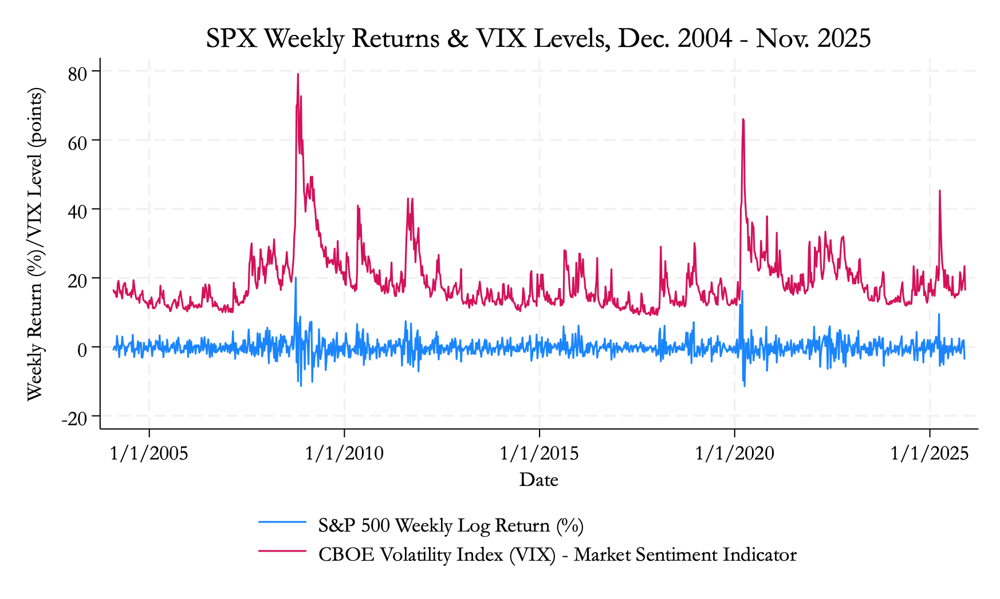

Figure 1 demonstrates consistent inverse co-movements between VIX levels and S&P 500 weekly returns over the sample period. When the VIX spikes, SPX returns tend to turn negative dramatically. This is best exemplified during the 2008 Global Financial Crisis and the COVID-19 market crash in March 2020. This persistent, negatively-correlated relationship, hence, provides a strong visual motivation for the negative VIX coefficient predicted by the main hypothesis. Notably, the VIX exhibits substantial mean reversion patterns, rapidly declining after crisis peaks, while also demonstrating lasting elevation during prolonged periods of market stress such as the 2011 European debt crisis and the 2015-2016 volatility episode.

**Figure 2: ETF-Specific Return and VIX Dynamics, Dec. 2004 to Nov. 2025**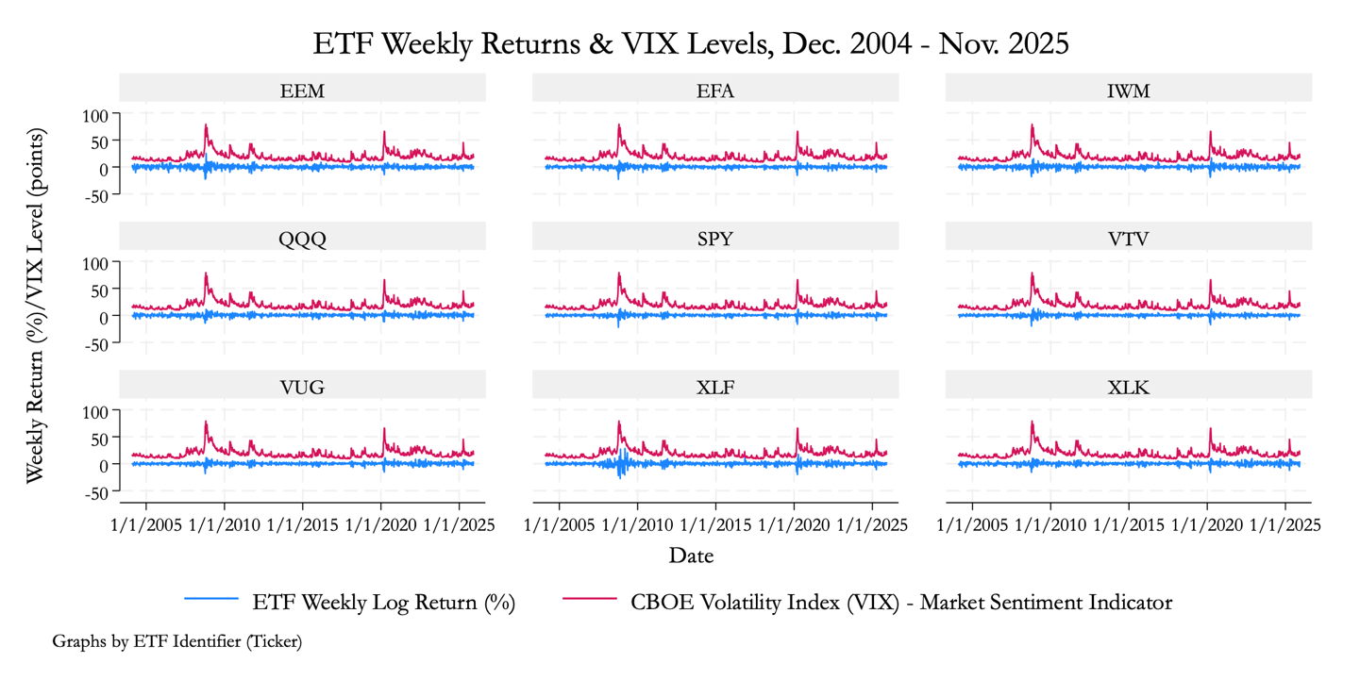

Figure 2 further shows how VIX spikes coincide with negative returns across all ETF categories, including broad market (SPY, QQQ), style factors (VTV, VUG), size (IWM), sectors (XLF, XLK), and international (EFA, EEM). It is worth-noting that XLF (financial sector) exhibits the strongest co-movements with high volatility regimes while VTV (large-cap value) appears among those with the least associations with VIX spikes in terms of magnitude.

**Figure 3: ETF Average Returns Across VIX Regimes, Dec. 2004 to Nov. 2025**

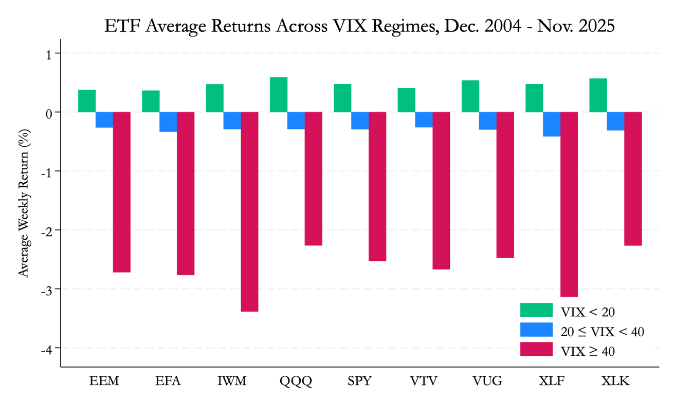

Figure 3 demonstrates the regime-dependent nature of the VIX-return relationship discussed in the literature review. All nine ETFs exhibit positive returns during low-volatility periods (VIX < 20) and negative returns during high-volatility periods (VIX ≥ 20). The consistency of this pattern across diverse market segments underscores the pervasive role of sentiment in driving contemporaneous equity performance.

### Data Limitations

Despite the high quality of Bloomberg data, several limitations remain. First, ETF-level fund flows and realized volatility measures are unavailable for all sample periods, preventing the inclusion of microstructure controls such as liquidity, creation–redemption activity, and trading volume. If these omitted factors correlate with volatility shocks, the estimated VIX coefficients may be biased. Second, since the VIX reflects U.S. implied volatility derived from S&P 500 options, it appears an imperfect proxy for sentiment affecting international ETFs (EFA, EEM). Observed effects on these funds may therefore capture global spillovers rather than purely domestic uncertainty, particularly if regional volatility dynamics differ from those in the U.S. Third, the use of weekly data sacrifices intraday variation and may attenuate short-lived volatility–return feedback or high-frequency rebalancing effects documented in prior work (Todorov, 2019). However, weekly aggregation reduces microstructure noise while preserving sufficient observations for panel estimation.

## Model Specifications

This study investigates how market sentiment affect ETF returns, controlling for macro-financial conditions and ETF-specific characteristics. The full-panel regression model is specified as:

$${fund_{ret}}_{i,t}=α_{i}+β_{1} {VIX}_{t}+β_{2}{spx_ret}_{t}+β_{3} {VIX×spx_ret}_{t}$$

$$+β_{4} {term_spread}_{t}+β_{5} {credit_spead}_{t}+ε_{i,t}$$

where $i$ indexes ETFs, $t$ indexes weeks, and all variables are defined in sub-section III.1 above. The model is estimated using ETF fixed effects with heteroskedasticity-robust standard errors clustered by ETF. The ETF-specific fixed effects ($α_{i}$) control for time-invariant characteristics (e.g., expense ratios, tracking design, latent risk exposures), while clustering addresses serial correlation in ETF returns driven by persistent volatility shocks.

Time fixed effects are excluded because the key regressors (VIX, market returns, and macro spreads) vary only across time. Including time effects would absorb their variation and preclude coefficient estimation. Instead, the model exploits joint time-series and cross-sectional variation, with regime dependence explored through robustness checks and ETF-specific analyses. Moreover, the interaction term($β_{3}$) captures asymmetry in volatility effects across market states, allowing sentiment shocks to affect returns differently during market rallies versus downturns.

Based on asset-pricing theory and prior evidence, I expect $β_{1}$  to be negative, as higher VIX reflects increased risk aversion and higher required returns. The market return coefficient $β_{2}$  should be positive, as ETFs tracking U.S. equity market segments should move directionally with the broader market index. Importantly, the sign of the interaction term $β_{3}$  is ambiguous and central to the analysis: a positive estimate would indicate that volatility is less harmful during market upswings (“good volatility”), while a negative estimate would imply amplified losses during downturns. The term spread coefficient $β_{4}$  is expected to be positive, reflecting stronger growth expectations under a steeper yield curve, while the credit spread coefficient $β_{5}$  should be negative, as widening spreads signal financial stress and weaker equity performance.

# Empirical Results

This section presents the empirical findings from the panel regression analysis examining the relationship between market sentiment (VIX) and ETF returns. Table 2 reports four model specifications that progressively incorporate market controls and interaction effects, while Table 3 presents ETF-specific estimates to assess heterogeneity across market segments.

## Full Panel Regression

Table 2 presents the baseline estimates of how changes in market volatility affect ETF returns. Column (1) reports a simple specification including only VIX and macroeconomic controls. Column (2) adds the S&P 500 return to account for general market movements. Column (3) introduces an interaction term between VIX and SPX returns to test whether volatility effects vary with market conditions. Column (4) presents random effects estimates as a robustness check.

**Table 2: The Effect of VIX on ETF Returns**

|  |  |  |  |  |
| --- | --- | --- | --- | --- |
|  | ***Dependent Variable: Weekly Log Returns of All ETFs (%)*** | | | |
|  | (1) | (2) | (3) | (4) |
| Models | VIX | + SPX Return | Interaction | Random Effects |
| VIX | -0.163** | -0.162** | -0.160** | -0.160** |
|  | (0.007) | (0.007) | (0.006) | (0.006) |
| SPX Returns |  | 0.047** | -0.101** | -0.101** |
|  |  | (0.009) | (0.017) | (0.017) |
| VIX * SPX Returns |  |  | 0.005** | 0.005** |
|  |  |  | (0.001) | (0.001) |
| Term Spread | 0.000 | -0.000 | -0.000 | -0.000 |
|  | (0.000) | (0.000) | (0.000) | (0.000) |
| Credit Spread | 0.022** | 0.022** | 0.022** | 0.022** |
|  | (0.001) | (0.001) | (0.001) | (0.001) |
| Constant | 0.985** | 0.981** | 0.951** | 0.951** |
|  | (0.059) | (0.060) | (0.057) | (0.049) |
|  |  |  |  |  |
| Observations | 10,251 | 10,242 | 10,242 | 10,242 |
| R-squared | 0.121 | 0.123 | 0.127 | 0.127 |
| *Notes:* See Table 1 for variable details. All models include ETF-level fixed (or random) effects of all 9 funds. Robust standard errors are in parentheses. The sample covers weekly data from December 2004 to November 2025. Asterisks denote significance at the following levels: ** p<0.01, * p<0.05. | | | | |

Table 2 provides strong evidence that increases in market volatility negatively affect ETF returns. The coefficient on VIX in column (1) indicates that a one-unit increase in VIX reduces ETF returns by 0.163%. This negative relationship persists when controlling for S&P 500 returns in column (2), with the VIX coefficient remaining virtually unchanged at -0.162. The direct effect of market returns is positive and significant (0.047), confirming that ETFs move with the broader market. However, the full specification in column (3) shows that while the standalone market return coefficient becomes negative (-0.101), the interaction term between VIX and SPX returns is positive and significant (0.005). This finding suggests that the negative impact of volatility on ETF returns is mitigated during periods of positive market performance. Put differently, when the market is rising, increased volatility is less detrimental to ETF returns. The credit spread coefficient is consistently positive and significant across all specifications (0.022), indicating that widening credit spreads, typically associated with financial stress, are paradoxically associated with higher ETF returns, possibly reflecting flight-to-quality dynamics or compensating risk premia. The random effects estimates in column (4) align with the fixed effects results, confirming that the findings are robust to alternative panel methods.

## ETF-Specific Results

To examine heterogeneity in how different equity market segments respond to volatility shocks, I estimate the full model specification separately for each of the nine ETFs in the sample. Table 3 reports these ETF-specific regression results, allowing us to assess whether volatility sensitivity varies across broad market indices, style factors, sectors, and international markets.

**Table 3: The Effect of VIX on Different ETFs**

|  |  |  |  |  |  |  |  |  |  |
| --- | --- | --- | --- | --- | --- | --- | --- | --- | --- |
|  | (1) | (2) | (3) | (4) | (5) | (6) | (7) | (8) | (9) |
| Specific ETF | EEM | EFA | IWM | QQQ | SPY | VTV | VUG | XLF | XLK |
|  | *Emerging* | *Developed* | *Small Cap* | *NASDAQ 100* | *S&P 500* | *Value* | *Growth* | *Financial* | *Tech* |
|  |  |  |  |  |  |  |  |  |  |
| VIX | -0.170** | -0.154** | -0.187** | -0.152** | -0.145** | -0.142** | -0.149** | -0.196** | -0.148** |
|  | (0.027) | (0.029) | (0.029) | (0.023) | (0.026) | (0.025) | (0.024) | (0.030) | (0.024) |
| SPX Returns | -0.120 | -0.074 | -0.059 | -0.075 | -0.095 | -0.044 | -0.102 | -0.216 | -0.126 |
|  | (0.130) | (0.103) | (0.115) | (0.081) | (0.091) | (0.090) | (0.083) | (0.147) | (0.084) |
| VIX * SPX Returns | 0.005 | 0.003 | 0.003 | 0.003 | 0.005 | 0.004 | 0.005 | 0.010 | 0.006 |
|  | (0.005) | (0.005) | (0.005) | (0.003) | (0.004) | (0.004) | (0.004) | (0.006) | (0.003) |
| Term Spread | -0.000 | -0.000 | 0.001 | -0.000 | -0.000 | 0.000 | -0.000 | 0.001 | -0.000 |
|  | (0.001) | (0.001) | (0.001) | (0.001) | (0.000) | (0.000) | (0.001) | (0.001) | (0.001) |
| Credit Spread | 0.025** | 0.021** | 0.026** | 0.022** | 0.020** | 0.018** | 0.021** | 0.024** | 0.021** |
|  | (0.004) | (0.004) | (0.005) | (0.003) | (0.004) | (0.004) | (0.004) | (0.007) | (0.004) |
| Constant | 0.785 | 0.840* | 0.999* | 0.948** | 0.913* | 0.903* | 0.954** | 1.303* | 0.910** |
|  | (0.497) | (0.380) | (0.417) | (0.319) | (0.359) | (0.361) | (0.326) | (0.659) | (0.321) |
|  |  |  |  |  |  |  |  |  |  |
| Observations | 1,138 | 1,138 | 1,138 | 1,138 | 1,138 | 1,138 | 1,138 | 1,138 | 1,138 |
| R-squared | 0.111 | 0.133 | 0.136 | 0.124 | 0.150 | 0.143 | 0.139 | 0.133 | 0.121 |
| *Notes:* See Table 1 for variable details. Robust standard errors are in parentheses. The dependent variable is the weekly log return of the ETF (in percent). The sample covers weekly observations from December 2004 to November 2025 Asterisks denote significance at the following levels: ** p<0.01, * p<0.05. | | | | | | | | | |

Table 3 reveals substantial heterogeneity in volatility sensitivity across different equity market segments. The financial sector ETF (XLF) exhibits the strongest sensitivity to VIX changes, with a coefficient of -0.196, suggesting that financial stocks are particularly vulnerable to sentiment shocks. This heightened sensitivity likely reflects the sector's inherent leverage and exposure to credit market conditions. Small-cap equities (IWM) also show elevated volatility sensitivity (-0.187), consistent with the hypothesis that smaller firms face greater financing constraints and investor risk aversion during periods of market stress.

Conversely, value stocks (VTV) display the lowest sensitivity to volatility changes (-0.142), potentially reflecting their defensive characteristics and lower beta profiles. The technology sector (XLK) shows moderate sensitivity (-0.148), though its interaction term with market returns is positive and marginally significant, suggesting that tech stocks benefit more than other sectors when rising markets coincide with elevated volatility. International equity ETFs show divergent patterns: emerging markets (EEM) exhibit relatively high sensitivity (-0.170), while developed markets ex-US (EFA) show more moderate effects (-0.154), consistent with the greater risk premia associated with emerging market exposures. Notably, the credit spread coefficient remains positive and significant across all ETFs, ranging from 0.018 to 0.026, reinforcing the robustness of this counterintuitive finding.

# Discussion & Conclusion

## Discussion

The empirical results provide strong support for my main hypothesis that increased market uncertainty, as measured by the VIX, negatively impacts ETF returns across major equity market segments. Particularly, a one-standard-deviation rise in the VIX (about 8.52 points) corresponds to a 1.36 percentage point decrease in ETF returns, which is nearly ten times the average weekly return of 0.15% in the sample. This economically and statistically significant effect highlights the influence of sentiment-driven volatility on short-term equity market performance.

The negative relationship between changes in the VIX and ETF returns across all model specifications aligns with behavioral finance and risk-return tradeoff theories. Higher implied volatility signals increased investor fear and uncertainty, leading to higher required returns and immediate price declines. Prior literature has established several forces driving this effect: increased risk aversion prompts portfolio rebalancing away from equities, liquidity provision becomes more costly during volatile periods, and market makers widen bid-ask spreads to compensate for inventory risk. This study’s findings then contribute to the literature by documenting that sentiment effects propagate broadly across equity markets, affecting not only broad indices but also specialized segments including value/growth factors, small caps, sectors, and international exposures.

The positive, statistically significant interaction between VIX levels and overall market returns is particularly notable. This finding suggests that the impact of shocks to investor sentiment varies: those occurring during periods of positive market performance are less detrimental to fund returns. Investors appear to distinguish between "good volatility" associated with market rallies and "bad volatility" linked to selloffs. Heightened volatility in bullish markets may indicate increased trading activity and enhanced price discovery, rather than solely reflecting risk aversion, thereby mitigating negative effects on returns. This distinction is important for portfolio management and risk forecasting, as volatility-based strategies should account for the prevailing market direction.

The heterogeneity analysis in Table 3 demonstrates varying degrees of vulnerability across market segments. The financial sector’s outsized sensitivity to volatility shocks (${\hat{β}}_{1}$ = -0.196) confirms its role in transmitting systemic risk and emphasizes important policy considerations for financial stability. Similarly, small-cap equities’ elevated sensitivity ( ${\hat{β}}_{1}$ = -0.187) supports the notion that smaller firms are disproportionately affected by shifts in risk appetite, primarily due to higher financing costs and lower liquidity buffers during market stress. Conversely, value stocks display lower sensitivity to volatility (${\hat{β}}_{1}$ = -0.142), suggesting that defensive investment strategies may offer protection against market selloffs, although such approaches could also constrain gains during subsequent recoveries.

Though counterintuitive at first glance, credit spread appear to be positively associated with fund returns. One plausible explanation is that widening credit spreads, particularly those driven by idiosyncratic corporate credit events rather than systemic risk, may coincide with flight-to-quality flows that benefit large-cap, liquid ETFs. Alternatively, the positive coefficient could indicate compensating risk premia that are realized in the cross-section, even as they predict negative future returns in time series. This result warrants further investigation using higher-frequency data and alternative measures of credit risk.

Several limitations are present in this study. First, the analysis focuses on contemporaneous weekly relationships, which may limit the generalizability of the findings to higher frequency timeframes. Second, since the VIX primarily captures U.S. equity market sentiment, using this index as a proxy for international sentiment may be suboptimal for ETFs like EFA or EEM. Third, the sample period covers more than 20 years and encompasses distinct market regimes, such as the Global Financial Crisis of 2008 and the COVID-19 market crash in 2020. Unique in their nature, these periods may exhibit volatility-return relationships that cannot be fully captured by linear models. Future research should consider time-varying parameters and threshold effects to better address these nonlinearities.

## Conclusion

This study examines how market sentiment, proxied by the CBOE Volatility Index (VIX), affects returns across nine major exchange-traded funds representing distinct equity market segments from December 2004 to November 2025. Panel fixed-effects regressions with ETF-clustered robust standard errors provide robust evidence that increases in the VIX exert significant negative effects on ETF returns. Specifically, a one-standard-deviation increase in VIX reduces average returns by approximately 1.36 percentage points. However, this relationship exhibits substantial heterogeneity across market segments and asymmetry across market conditions.

Analysis of individual ETFs reveals two additional core findings. First, volatility sensitivity varies systematically across equity segments. Financial and small-cap ETFs exhibit approximately 35-40% greater sensitivity to sentiment shocks than value-oriented funds, reflecting differences in leverage, liquidity, and exposure to risk appetite. Second, volatility effects are asymmetric. The positive and significant interaction between VIX and market returns indicates that volatility shocks are significantly less damaging during market rallies than during selloffs. This pattern is consistent with investors distinguishing between “good” volatility associated with price discovery and “bad” volatility driven by risk aversion.

These results advance the literature on investor sentiment and asset pricing in several ways. While prior studies typically focus on broad indices or volatility products in isolation, this study provides the first comprehensive panel evidence comparing sentiment sensitivity across the full spectrum of equity market segments using a unified empirical framework. The documented heterogeneity in VIX exposure offers both empirical insight and practical relevance, demonstrating that sentiment risk is neither uniform nor incidental across markets. Moreover, by explicitly modeling interaction effects, this study extends prior work demonstrating regime-dependent relationships (Dutta et al., 2020; Bekaert and Hoerova, 2014) to show that the VIX-return relationship depends critically on market direction, not merely volatility regime.

The findings carry practical implications for investors, portfolio managers, and policymakers. For practitioners, volatility-based hedging strategies appears effective for portfolios concentrated in sentiment-sensitive segments, like financials and small-cap equities. The observed asymmetry in volatility effects suggests that risk management strategies need to account for market direction, beyond static hedging rules. Cross-sectional variation in sentiment exposure creates opportunities to manage volatility risk by reallocating portfolios toward more defensive segments during periods of heightened uncertainty. From a policy perspective, these results highlight the broader economic costs associated with increased market uncertainty. Volatility-induced declines in equity markets can tighten financial conditions and dampen real economic activity. The financial sector’s pronounced sensitivity further reinforces its role as a conduit for systemic risk. Integrating sentiment indicators with traditional credit and liquidity measures may enhance financial stability surveillance.

Several avenues for future research remain. Extending the analysis to longer horizons could clarify whether sentiment effects reflect temporary price pressure or persistent risk premia. Incorporating ETF-level flows and microstructure variables would enable more direct testing of transmission mechanisms. Modeling regime-switching or time-varying parameters could capture nonlinearities across market states. Expanding the framework to other asset classes would provide a more comprehensive view of sentiment propagation.

Despite acknowledged limitations, including the contemporaneous focus with weekly data, the potential misuse of VIX as a proxy for international sentiment, and the challenge of modeling regime-specific dynamics in a linear framework, this study demonstrates that market sentiment is a primary determinant of short-run ETF performance. The magnitude, pervasiveness, and systematic heterogeneity of volatility effects underscore the central role of behavioral forces in modern equity markets and reinforce the importance of incorporating sentiment measures into asset pricing, portfolio construction, and risk management frameworks.

# References

Baker, Malcolm, and Jeffery Wurgler. 2006. “Investor Sentiment and the Cross-Section of Stock Returns.” *The Journal of Finance* 61 (4): 1645–80. https://doi.org/10.1111/j.1540-6261.2006.00885.x.

Barber, Brad M., and Terrance Odean. 2008. “All That Glitters: The Effect of Attention and News on the Buying Behavior of Individual and Institutional Investors.” *Review of Financial Studies* 21 (2): 785–818.

Bekaert, Geert, and Marie Hoerova. 2014. “The VIX, the Variance Premium and Stock Market Volatility.” *Journal of Econometrics* 183 (2): 181–92. https://doi.org/10.1016/j.jeconom.2014.05.008.

Bollerslev, Tim, George Tauchen, and Hao Zhou. 2009. “Expected Stock Returns and Variance Risk Premia.” *Review of Financial Studies* 22 (11): 4463–92. https://doi.org/10.1093/rfs/hhp008.

Campbell, John Y. 1993. “Intertemporal Asset Pricing without Consumption Data.” *The American Economic Review* 83 (3): 487–512. https://doi.org/10.2307/2117530.

Campbell, John Y. 1996. “Understanding Risk and Return.” *Journal of Political Economy* 104 (2): 298–345. https://doi.org/10.1086/262026.

Campbell, John Y., and John H. Cochrane. 1999. “By Force of Habit: A Consumption‐Based Explanation of Aggregate Stock Market Behavior.” *Journal of Political Economy* 107 (2): 205–51.

Chang, Chia-Lin, Tai-Lin Hsieh, and Michael McAleer. 2018. “Connecting VIX and Stock Index ETF with VAR and Diagonal BEKK.” *Journal of Risk and Financial Management* 11 (4): 58. https://doi.org/10.3390/jrfm11040058.

Chen, Yu-Lun, and Wei-Che Tsai. 2017. “Determinants of Price Discovery in the VIX Futures Market.” *Journal of Empirical Finance* 43 (September): 59–73. https://doi.org/10.1016/j.jempfin.2017.05.002.

Cheng, Minder, and Ananth Madhavan. 2009. “The Dynamics of Leveraged and Inverse Exchange-Traded Funds.” *Journal of Investment Management* 7 (4): 43–62.

Deng, Geng, Craig McCann, and Olivia Wang. 2012. “Are VIX Futures ETPs Effective Hedges?” *The Journal of Index Investing* 3 (3): 35–48. https://doi.org/10.3905/jii.2012.3.3.035.

Dutta, Anupam, Elie Bouri, Tareq Saeed, and Xuan Vinh Vo. 2020. “Impact of Energy Sector Volatility on Clean Energy Assets.” *Energy* 212 (December): 118657. https://doi.org/10.1016/j.energy.2020.118657.

Giot, Pierre. 2005. “Relationships between Implied Volatility Indexes and Stock Index Returns.” *The Journal of Portfolio Management* 31 (3): 92–100. https://doi.org/10.3905/jpm.2005.500363.

Park, Minjae, Mi Lim Lee, and Jinpyo Lee. 2019. “Predicting Stock Market Indices Using Classification Tools.” *Asian Economic and Financial Review* 9 (2): 243–56. https://doi.org/10.18488/journal.aefr.2019.92.243.256.

Shiller, Robert J. 2001. *Irrational Exuberance : With a New Preface*. Princeton, Nj: Princeton Univ. Press. http://www.library.fa.ru/files/Shiller2.pdf.

Whaley, Robert E. 2009. “Understanding the VIX.” *The Journal of Portfolio Management* 35 (3): 98–105. https://doi.org/10.3905/jpm.2009.35.3.098.